

**CAPSTONE PROJECT REPORT**

**Report 2 – Project Management Plan**

– Hanoi, August 2019 –

**Table of Contents**

I. Record of Changes 3

II. Project Management Plan 4

1. Overview 4

1.1 Scope & Estimation 4

1.2 Project Objectives 4

1.3 Project Risks 4

2. Management Approach 5

2.1 Project Process 5

2.2 Quality Management 5

2.3 Training Plan 5

3. Project Deliverables 5

4. Responsibility Assignments 5

5. Project Communications 6

6. Configuration Management 6

6.1 Document Management 6

6.2 Source Code Management 6

6.3 Tools & Infrastructures 6

# I. Record of Changes

| **Date** | **A* M, D** | **In charge** | **Change Description** |
| --- | --- | --- | --- |
| 25/09/2025 | A | hieuddhe176719 | Write Project management plan |
|  |  |  |  |
|  |  |  |  |
|  |  |  |  |
|  |  |  |  |
|  |  |  |  |
|  |  |  |  |
|  |  |  |  |
|  |  |  |  |
|  |  |  |  |
|  |  |  |  |
|  |  |  |  |
|  |  |  |  |

*A - Added M - Modified D - Deleted

# II. Project Management Plan

## 1. Overview

### 1.1 Scope & Estimation

The Blue Dolphin Preschool Management System is a centralized digital platform designed to support the school board, teachers, accountants, nutrition and facilities staff, as well as parents. Its scope covers key modules such as classroom and timetable management, student information and attendance tracking, financial management for tuition and expenses, nutrition and facilities management, and a parent portal for accessing schedules, menus, student updates, online payments, and communication with teachers. More details about the project scope and specific components will be described in Table 2 below:

Table Work Breakdown Structure and Estimation

| **#** | **WBS Item** | **Complexity** | **Est. Effort**  **(man-days)** |
| --- | --- | --- | --- |
| ***1*** | ***System Administration*** |  | ***41*** |
| 1.1 | Login / Logout | Medium | 3 |
| 1.2 | Account Management | Medium | 8 |
| 1.3 | Role & Permission Management | Complex | 18 |
| 1.4 | Dashboard | Medium | 12 |
| ***2*** | ***Academic Management*** |  | ***105*** |
| 2.1 | Academic Year Management | Medium | 12 |
| 2.2 | Curriculum Framework Management | Complex | 15 |
| 2.3 | Student Management | Complex | 15 |
| 2.4 | Teacher Management | Medium | 10 |
| 2.5 | Parent Management | Medium | 8 |
| 2.6 | Student List View | Simple | 3 |
| 2.7 | Student Health Profile | Medium | 8 |
| 2.8 | Attendance, Comments, Photo Upload | Complex | 15 |
| 2.9 | Leave Request (Student/Teacher) | Medium | 10 |
| 2.10 | Leave Approval | Medium | 8 |
| ***3*** | ***Facilities & Administration*** |  | ***66*** |
| 3.1 | Classroom Management | Medium | 8 |
| 3.2 | Room Management | Medium | 8 |
| 3.3 | Meal/Nutrition Management | Complex | 15 |
| 3.4 | Supplier Ordering | Medium | 10 |
| 3.5 | Supplier Management | Medium | 8 |
| 3.6 | Nutrition Reports | Medium | 8 |
| ***4*** | ***Finance & Accounting*** |  | ***71*** |
| 4.1 | Tuition Fee Management | Complex | 15 |
| 4.2 | Online Tuition Payment | Complex | 15 |
| 4.3 | Fund/Balance Management | Complex | 12 |
| 4.4 | Financial Reports (Revenue/Expense) | Complex | 12 |
| 4.5 | Invoice & Receipt Generation | Medium | 9 |
| 4.6 | Payroll Management | Medium | 9 |
| ***5*** | ***Parent Portal*** |  | ***68*** |
| 5.1 | Child’s Schedule View | Simple | 3 |
| 5.2 | Meal Menu View | Simple | 3 |
| 5.3 | Personal Info View (Student/Parent) | Medium | 8 |
| 5.4 | Photo Album | Medium | 10 |
| 5.5 | Health Report | Medium | 8 |
| 5.6 | Academic Report (Activities, Extracurricular) | Complex | 12 |
| 5.7 | Parent Chat | Complex | 15 |
| ***6*** | ***Integration*** |  | ***00*** |
| 6.1 |  |  |  |
| 6.2 |  |  |  |
| ***7*** | ***Testing*** |  | ***71*** |
| 7.1 |  |  |  |
| 7.2 |  |  |  |
| 7.3 |  |  |  |
| ***8*** | ***Training and Handover*** |  | ***9*** |
| 8.1 | Train the SMIA department to use the software | Medium | 3 |
| 8.2 | Write user manuals for end users | Medium | 3 |
| 8.3 | Provide guidance to system administrators on usage | Medium | 3 |
| ***9*** | ***Maintenance*** |  | 30 |
| 9.1 | Provide guidance to system administrators on usage | Medium | 30 |
| ***Total Estimated Effort (man-days)*** | | | ***21*** |

### 1.2 Project Objectives

| **#** | **Testing Stage** | **Test Coverage** | **No. of Defects** | **% of Defect** | **Notes** |
| --- | --- | --- | --- | --- | --- |
| 1 | Reviewing | ~90% (requirement & design documents) | 15 | 10% | Mainly detects errors in requirement specifications, unclear design documents. |
| 2 | Unit Test | ~80% (functions & modules) | 40 | 25% | Incomplete syntax, logic, validation errors. |
| 3 | Integration Test | ~75% (interfaces between modules) | 50 | 30% | Errors due to interactions between subsystems, APIs are not synchronized. |
| 4 | System Test | ~85% (end-to-end business scenarios) | 45 | 25% | Errors in business flow, performance, UI/UX are not suitable. |
| 5 | Acceptance Test | ~70% (UAT by client) | 15 | 10% | Minor errors related to usability, requiring adjustments |

**Milestone Timeliness (%):** 95% (expected to complete most milestones on time, with buffer for testing & fixing).

**Allocated Effort (man-days):** Approximately 70 man-days for all testing activities (~20% of total effort 351 man-days).

### 1.3 Project Risks

In any digital transformation project, assessing and managing risks is an essential part of ensuring success. The Blue Dolphin Preschool Management System is no exception. Table 5 describes the potential risks of the project, along with their impact level, likelihood, and mitigation plan.

| **#** | **Risk Description** | **Impact** | **Possibility** | **Response Plans** |
| --- | --- | --- | --- | --- |
| 1 | Changing requirements | High | Medium | Define and agree on scope early on. Set up a clear change request process, only approve changes that are essential. |
| 2 | Technical integration issues | High | Medium | Conduct early prototyping and integration testing. Choose technologies familiar to the development team. |
| 3 | Data security and privacy | Very High | Medium | Apply strong encryption, clear access control, regular backups, and perform security testing. |
| 4 | User adoption challenges | High | High | Provide user training sessions, simple quick-start guides, intuitive UI/UX, and responsive support channels. |
| 5 | Resource shortage | Medium | Medium | Maintain backup resources, document thoroughly for handovers, and balance workloads across the team. |
| 6 | Resource Constraints and Time Limitations | High | Medium | Clearly define the project scope, formulate a detailed plan, monitor progress rigorously, and prepare contingency plans for adjustments as needed. |

## 2. Management Approach

The Blue Dolphin Preschool has been actively modernizing its operations to improve communication between teachers and parents, streamline administrative tasks, and ensure high-quality early childhood education. Since the requirements involve dynamic interactions with multiple stakeholders—teachers, staff, and parents—flexibility and adaptability are essential. In this context, the **Scrum framework** is the most suitable choice because it allows the project team to deliver value iteratively, adapt quickly to feedback, and continuously refine the system.

Scrum emphasizes short development cycles (Sprints), frequent reviews, and close collaboration with stakeholders, which fits well with the preschool environment where user needs may evolve as the system is adopted. Each sprint enables the team to deliver working features—such as attendance tracking, parent communication modules, or fee management—that can be immediately tested and improved based on real user feedback. By breaking down the project into manageable increments, Scrum reduces the risk of misalignment with stakeholder expectations and ensures that the final product meets both functional and usability requirements.

### 2.1 Project Process

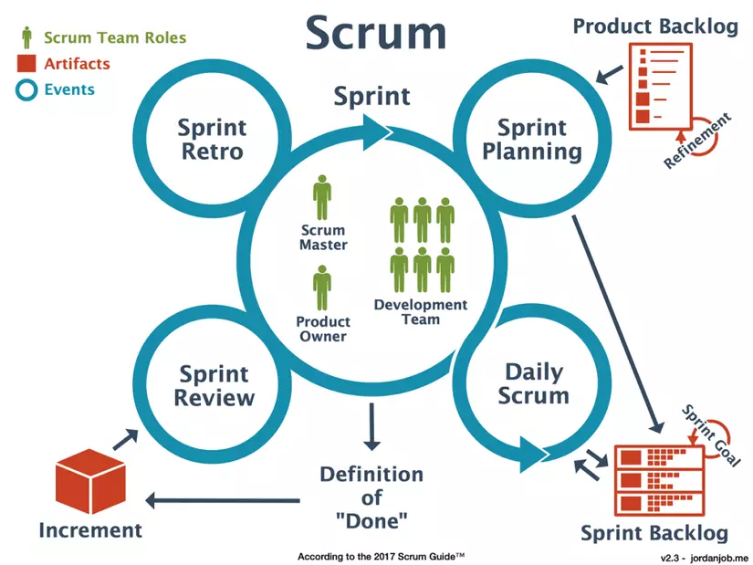

*The Scrum model is an empirical process management model that includes transparency, inspection, and adaptation.*

Product Backlog: A prioritized list of all features, improvements, and fixes required for the system. Maintained and refined continuously by the Product Owner with input from teachers, parents, and school administrators.

Sprint Planning: At the start of each sprint, the team selects a set of high-priority items from the Product Backlog to deliver within a fixed timebox (usually 2–4 weeks). The sprint goal is defined to keep the team focused on a clear objective.

Sprint Execution: During the sprint, the development team designs, codes, and tests features iteratively. Daily Scrum (a 15-minute stand-up meeting) ensures coordination, identifies blockers, and tracks progress.

Increment (Working Software): At the end of each sprint, the team delivers a working piece of software that can be demonstrated to stakeholders.

Sprint Review: The increment is demonstrated to stakeholders (teachers, staff, parents) to collect immediate feedback. Adjustments to the backlog are made based on this feedback.

Sprint Retrospective: The team reflects on what went well, what could be improved, and how to make the next sprint more effective.

Iteration: The cycle repeats with updated priorities, ensuring continuous improvement and alignment with stakeholder needs.

*Scrum team is divided into 3 roles including the following components:*

Product Owner: The Product Owner's task is to ensure the management of the remaining work (Product backlog) of software product development. The Product Owner must continuously update information for team members so that they understand the requirements or features needed for the product even if they do not directly develop that feature.

Development Team: is a software developer (Developer, Tester, Comtor, BA...) who will participate in the development of each specific feature. A development team usually includes from 3 to 9 members. These software developers may have different skills and some will be good at certain skills. However, when using Scrum, all members of the Development Team are required to be able to work in each other's place and no one is only responsible for developing one (or several) certain features.

Scrum Master: will be responsible for planning to assign work, prioritizing which backlog tasks in the Backlog to resolve first, organizing meetings with the Product Owner to monitor the situation and grasp necessary information.

### 2.2 Quality Management

2.2.1 Quality Objective

Objectives of Quality Management

Ensure usability and accessibility: The system must provide a simple and user-friendly interface so that teachers, staff, and parents can easily use it regardless of their technical background.

Guarantee data accuracy and security: Student and parent information, attendance records, and fee data must be stored accurately and protected against unauthorized access or data loss.

Maintain consistency across modules: All system features—such as attendance tracking, communication, fee management, and reporting—must work in harmony without conflicting errors or inconsistent outputs.

Enhance reliability and maintainability: The system should operate stably during daily preschool activities and be designed for straightforward updates, bug fixes, and future expansions.

To achieve these objectives, the project team will adhere to a structured set of quality assurance processes, including: Source Code Control, Testing and Feedback Control, Design Control, and Change Requirement Control.

2.2.2 Quality Assurance Process

**Source Code Control:** All development activities will be tracked using a version control system (e.g., Git). This ensures that every change—whether it is a bug fix, a new feature such as the attendance module, or an update to the parent notification function—is recorded and can be traced back. version control also helps coordinate multiple developers working on different modules (e.g., communication vs. finance), reducing conflicts and maintaining consistency across the codebase.

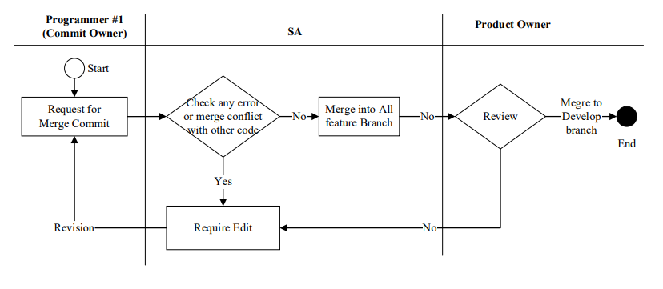

**Testing and Feedback Control:** Each sprint deliverable will go through multiple levels of testing, including unit tests, integration tests, and user acceptance testing. Teachers and parents will be directly involved in providing feedback on features such as attendance tracking, daily activity reports, and tuition notifications. This real-world feedback loop ensures that the software not only works technically but also fits smoothly into the daily operations of the preschool.

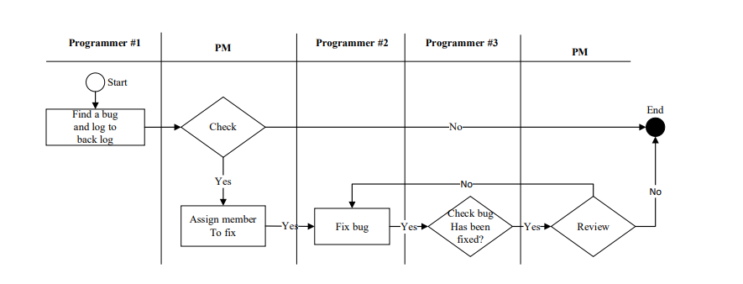

**Design Control:** The system’s design (database, user interface, and workflow diagrams) will be reviewed and validated against the original requirements. For example, the student record management module must be consistent with both the parent communication module and the finance system to avoid duplicated or inconsistent data. Maintaining strong design control ensures that all components integrate seamlessly, creating a reliable and predictable user experience.

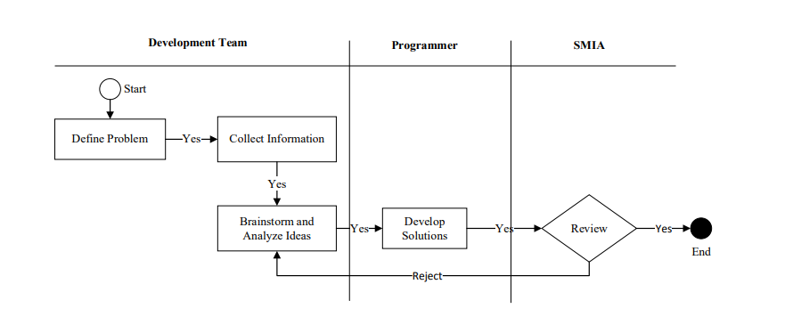

**Change Requirement Control:** Since preschool operations may evolve (e.g., introducing new learning reports for parents or digital payments for fees), change requests are expected during the project lifecycle. Each request will be formally documented, evaluated for impact on scope, time, and cost, and then approved or rejected by the Product Owner in consultation with stakeholders. This process prevents scope creep while still allowing flexibility to adapt the system to genuine needs.

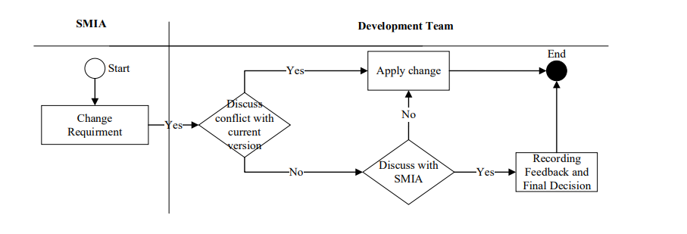

### 2.3 Training Plan

To ensure consistency and enhance the skills of the project team, a detailed training plan has been developed to provide the necessary knowledge about the technologies and tools used in the project. This plan ensures that all members have the same foundational knowledge, thereby optimizing work performance and collaboration among team members.

| **Training Area** | **Participants** | **When, Duration** | **Waiver Criteria** |
| --- | --- | --- | --- |
| React, NodeJS, MongoDB, Azure | All team members | 23/09/2025 - 28/09/2025 | Mandatory |
| Github | All team members | 24/09/2025 - 26/09/2025 | Mandatory |
| Jira | All team members | 26/09/2025 - 26/09/2025 | Mandatory |
| Specific Functional Training | End-users (Role-specific) | TBA | Mandatory |

## 3. Project Deliverables

In this section, we present a comprehensive overview of the key milestones in the system development process, detailed in the table below

*[Given the main project deliverables. Those can be internal and/or external deliverables. Students can prepare master schedule like the table format as below or in the more detailed structure as the sample in the attached sample file -* ***Report2_Sample High Level Project Schedule.pdf****]*

| **#** | **Deliverable** | **Due Date** | **Notes** |
| --- | --- | --- | --- |
| 1 | Start the project | 08/09/2025 | Receive requests and existing issues from customers |
| 2 | Get customer feedback | 10/09/2025 | Discuss some more unclear issues |
| 3 | Writing documents | 15/09/2025 | Write detailed documentation for each function |
| 4 | Receive source code | 20/09/2025 | Receive product source code and GitHub account |
| 5 | Interface Mockup Drawing | 23/09/2025 | Drawing interface by PMS |
| 6 |  |  |  |
| 7 |  |  |  |
| 8 |  |  |  |
| 9 | Deploy server test | 20/11/2025 | Deploy on test server |
| 10 | Confirm product acceptance | 23/11/2025 | Complete demo and product acceptance |
| 11 | Maintain System | 30/01/2025 | Key activities include bug fixing, performance optimization, feature updates, and technical support, ensuring the system to meet users' needs |

## 4. Responsibility Assignments

*D~Do; R~Review; S~Support; I~Informed; <blank>- Omitted*

| **Responsibility** | **HieuBTHE173123** | **KienPD**  **HE170155** | **HieuDDHE176719** | **ViNTKHE176898** | **TrangTPDHE172319** | **PSMStaff** |
| --- | --- | --- | --- | --- | --- | --- |
| Project Planning & Tracking | R | S | D | R | R |  |
| Prepare Project Introduction Document | R | S | S | D | D |  |
| Prepare SRS Document (Overview Part) | R | S | S | D | D | I |
| Prepare SRS Document (User Requirements) | R | S | S | D | D | I |
| … |  |  |  |  |  |  |

## 5. Project Communications

| **Communication Item** | **Who/ Target** | **Purpose** | **When, Frequency** | **Type, Tool, Method(s)** |
| --- | --- | --- | --- | --- |
| Daily Meeting | All team members | Check progress of assigned tasks Assign new tasks to team members | 9h00 PM every day | Online meetings |
| Weekly Meeting | All team members, PMS | Provide updates on progress, discuss issues and plans | Usually on weekends | Online meetings |
| Meeting with Supervisor | All team members, Supervisor | Check progress of project Discuss existing problems and new requirements | Once a week on 10h00 PM, Saturday | Online meetings |
| Emergency Meeting | All team members | Discuss and solve critical problems | When critical problems arise | Online meetings |

## 6. Configuration Management

### 6.1 Document Management

Document and asset management is a crucial factor in the development project of the Blue Dolphin Preschool Management System. This management ensures that all related documents and assets are organized and protected effectively, maintaining their integrity and ensuring easy access when needed.

Document Storage: Tools management is Google Drive, an online document storage service that helps store and share documents safely and conveniently.

Document Creation and Management: Tools management MS Office, a suite of office tools including Word and Excel, used for creating various project documents from design documents to project plans.

Diagramming and Documentation: Tools management is [draw.io](http://draw.io), A diagramming tool used to create flowcharts, organizational charts, and other visual representations essential for planning and documentation.

### 6.2 Source Code Management

Source code management is a crucial part of the software development process, helping to maintain the stability and quality of the system. In this project, we use GitHub as the platform for source code management and follow strict guidelines to ensure that the development process is carried out efficiently and in an organized manner.

Development Branch: develop

Programmer Member Branch : < features/name_member/feature_x>

### 6.3 Tools & Infrastructures

| **Category** | **Tools / Infrastructure** |
| --- | --- |
| **Technology** | ReactTS, NodeJS(v22) |
| **Database** | MongoDB, Firebase |
| **IDEs/Editors** | Visual Studio Code |
| **Diagramming** | DrawIO |
| **Documentation** | Ms Office, Google Docs/Sheets/Slides |
| **Version Control** | GitHub(Source Codes), Google Drive (Documents), GitHub action |
| **Deployment server** | Microsoft Azure Web Service |
| **Project management** | Jira, GitHub(Tasks, Defects) |